NAND-Based Digital Logic Library
- FPGA target: Spartan-7, xc7s50csga324-1
- Tool: AMD Vivado 2025.2

Gate 1 — NAND Gate

1. Objective
2-input NAND gate using

2. Boolean Equation
$$Y=\overline{\left\{A⋅B\right\}}$$

3. Verilog RTL — nand_gate.v
module nand_gate(
input a,
input b,
output y
);

assign y = ~(a & b);

endmodule

4. Testbench — tb_logic_gates.v
`timescale 1ns / 1ps

module tb_logic_gates;

reg a;
reg b;
wire y;

nand_gate dut (
.a(a),
.b(b),
.y(y)
);

initial begin
a = 0; b = 0; #10;
$display("a=%b b=%b y=%b", a, b, y);

a = 0; b = 1; #10;
$display("a=%b b=%b y=%b", a, b, y);

a = 1; b = 0; #10;
$display("a=%b b=%b y=%b", a, b, y);

a = 1; b = 1; #10;
$display("a=%b b=%b y=%b", a, b, y);

$finish;
end

endmodule

5. Truth Table
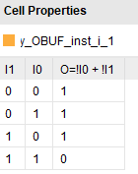
WAVEFORM:

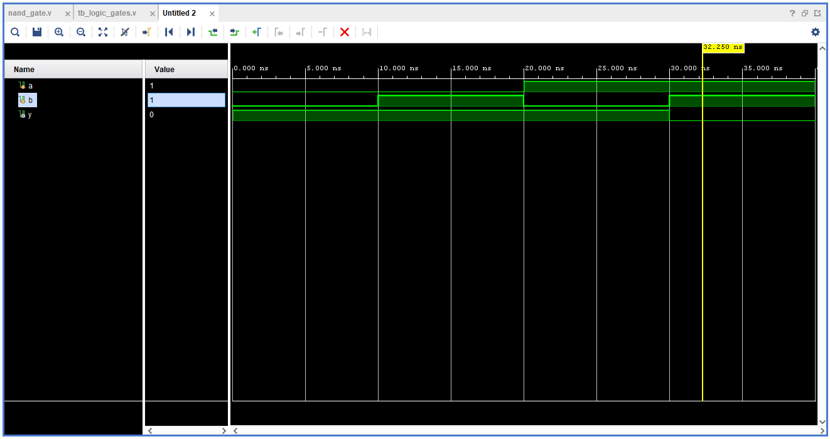

6. Synthesis Observations
SCHEMATIC:
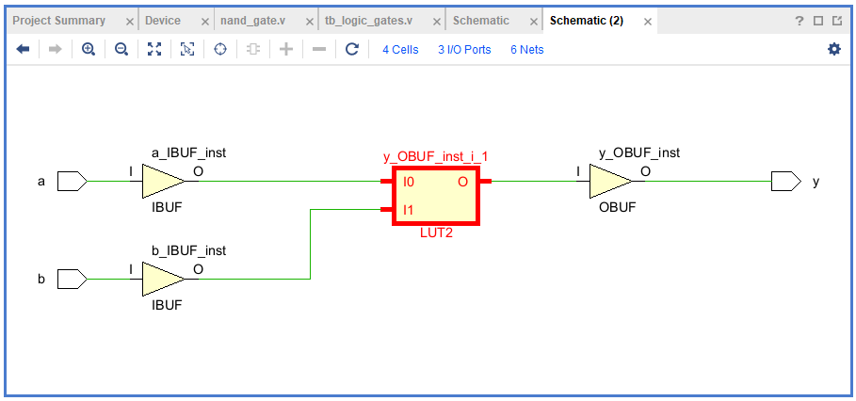
- Mapping: LUT2 with input buffers (IBUF) and output buffer (OBUF)
- LUT initialization value: 4'h7
The LUT initialization value encodes the NAND truth table under the standard LUT input convention.

Gate 2 — NOT Gate (Using NAND)

1. Objective
To design and verify a NOT gate by instantiating the previously designed 2-input NAND gate using Verilog structural modeling

2. Boolean Equation
Y = NOT(A)
$$Y = {\left(A\right)}^{'}$$

3. Verilog RTL — not_gate.v
module not_gate(
input a,
output y
);

nand_gate n1 (
.a(a),
.b(a),
.y(y)
);

endmodule

4. Testbench — tb_not_gate.v
`timescale 1ns / 1ps

module tb_not_gate;

reg a;
wire y;

not_gate dut (
.a(a),
.y(y)
);

initial begin
a = 0; #10;
$display("a=%b y=%b", a, y);

a = 1; #10;
$display("a=%b y=%b", a, y);

$finish;
end

endmodule

5. Truth Table
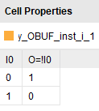

WAVEFORM

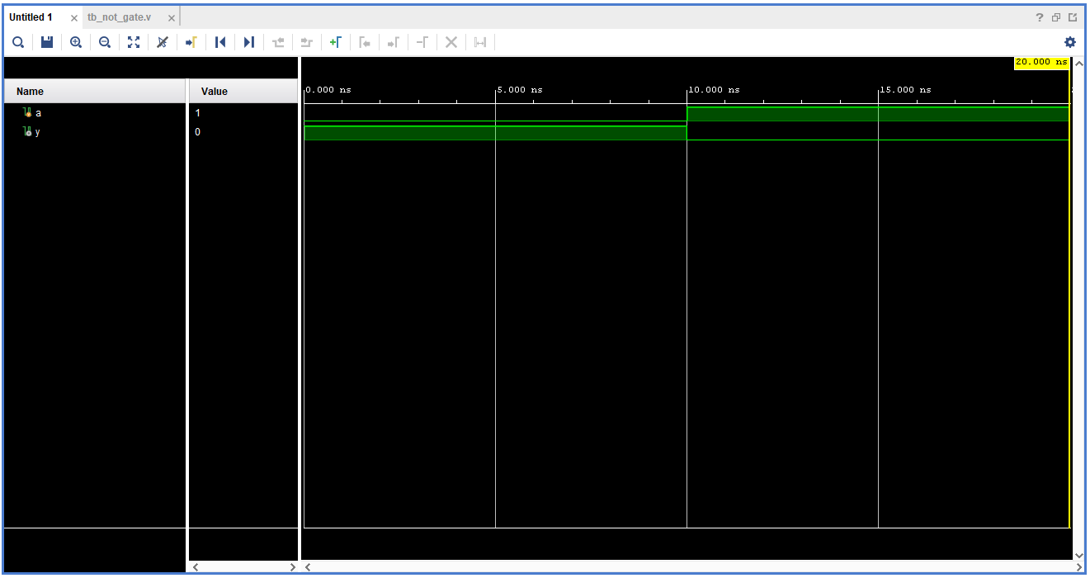
Tcl Console output:
a=0 y=1
a=1 y=0

6. Synthesis Observations
SCHEMATIC:
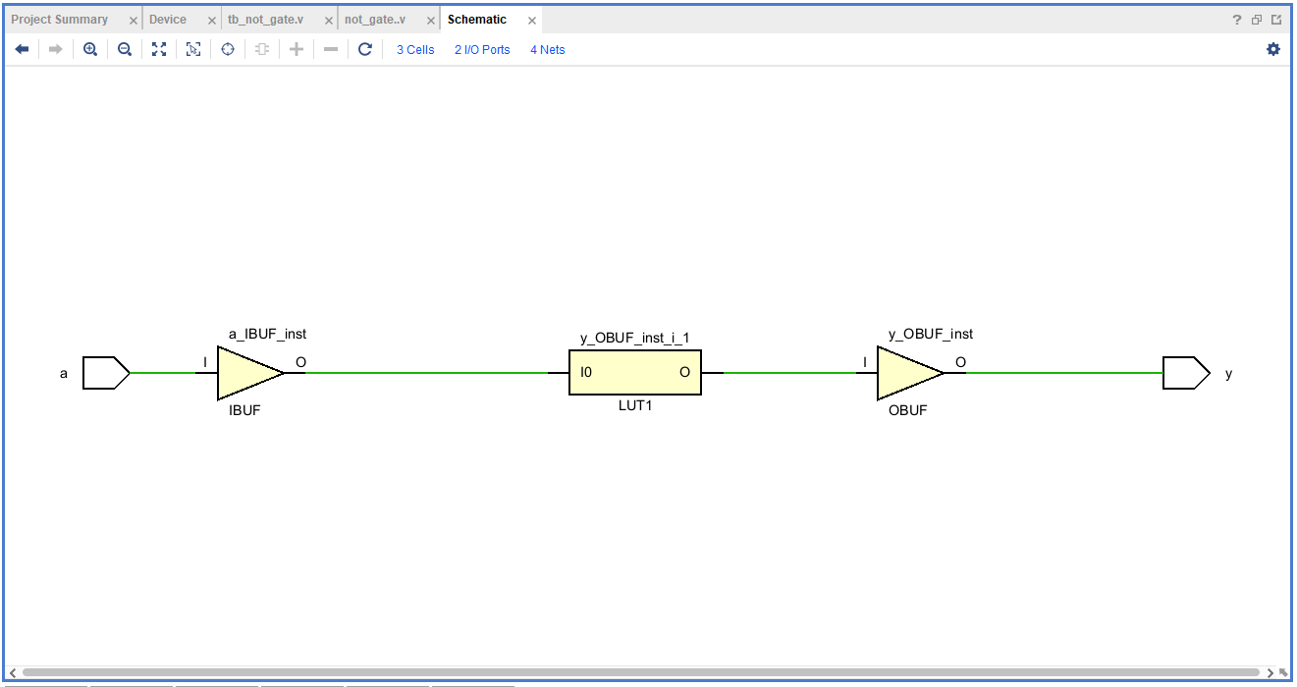
- Mapping: LUT1 with input buffer (IBUF) and output buffer (OBUF).
- LUT initialization value: 2'h1.
The LUT initialization value 2'h1 corresponds to the binary configuration 2'b01. It produces an output of 1 for input 0 and an output of 0 for input 1, implementing the NOT function.

Gate 3 — AND Gate Using NAND + NOT

1. Objective
To design and verify a 2-input AND gate by instantiating the previously designed NAND and NOT gates using Verilog structural modeling.

2. Boolean Equation
Y = A AND B
Y = A · B

3. Verilog RTL — and_gate.v
module and_gate(
input a,
input b,
output y
);

wire n;

nand_gate n1 (
.a(a),
.b(b),
.y(n)
);

not_gate n2 (
.a(n),
.y(y)
);

endmodule

4. Testbench — tb_and_gate.v
`timescale 1ns / 1ps

module tb_and_gate;

reg a;
reg b;
wire y;

and_gate dut (
.a(a),
.b(b),
.y(y)
);

initial begin
a = 0; b = 0; #10;
$display("a=%b b=%b y=%b", a, b, y);

a = 0; b = 1; #10;
$display("a=%b b=%b y=%b", a, b, y);

a = 1; b = 0; #10;
$display("a=%b b=%b y=%b", a, b, y);

a = 1; b = 1; #10;
$display("a=%b b=%b y=%b", a, b, y);

$finish;
end

endmodule

5. Truth Table
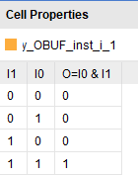

WAVEFORM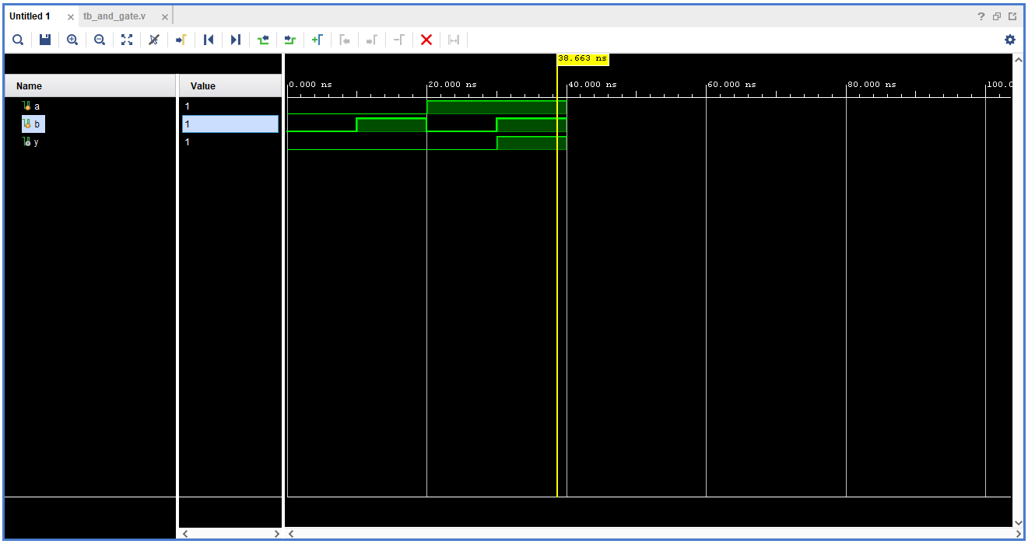
Tcl Console output:
a=0 b=0 y=0
a=0 b=1 y=0
a=1 b=0 y=0
a=1 b=1 y=1

6. Synthesis Observations
SCHEMATIC:
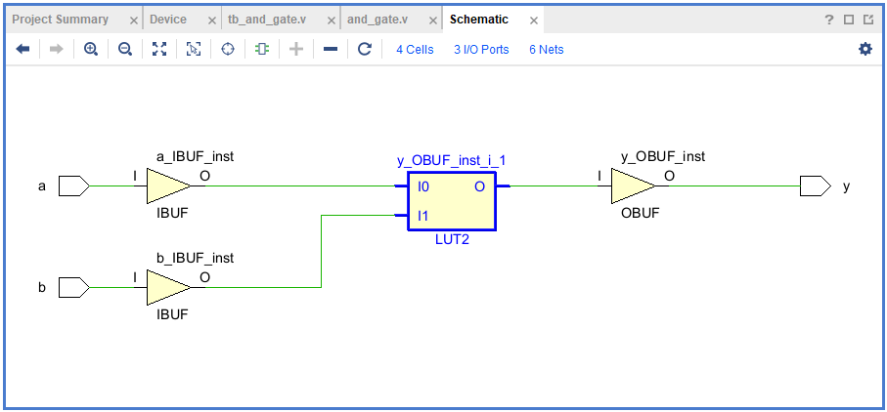
- Mapping: LUT2 with input buffer (IBUF) and output buffer (OBUF) is the expected implementation on the selected Spartan-7 FPGA, provided synthesis optimizes the logic into one LUT.
- LUT initialization value: INIT: 4'h8 (as observed).
The LUT initialization value 4'h8 corresponds to the binary configuration 4'b1000. For a two-input LUT, this configuration produces an output of 1 only when both inputs are 1, implementing the AND function.

Gate 4 — OR Gate Using NOT + NAND

1. Objective
To design and verify a 2-input OR gate by instantiating the previously designed NOT and NAND gates using Verilog structural modeling.

2. Boolean Equation
Y = A OR B
Y = A + B

3. Verilog RTL — or_gate.v
module or_gate(
input a,
input b,
output y
);

wire na;
wire nb;

not_gate n1 (
.a(a),
.y(na)
);

not_gate n2 (
.a(b),
.y(nb)
);

nand_gate n3 (
.a(na),
.b(nb),
.y(y)
);

endmodule

4. Testbench — tb_or_gate.v
`timescale 1ns / 1ps

module tb_or_gate;

reg a;
reg b;
wire y;

or_gate dut (
.a(a),
.b(b),
.y(y)
);

initial begin
a = 0; b = 0; #10;
$display("a=%b b=%b y=%b", a, b, y);

a = 0; b = 1; #10;
$display("a=%b b=%b y=%b", a, b, y);

a = 1; b = 0; #10;
$display("a=%b b=%b y=%b", a, b, y);

a = 1; b = 1; #10;
$display("a=%b b=%b y=%b", a, b, y);

$finish;
end

endmodule

5. Truth Table
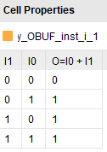

WAVEFORM
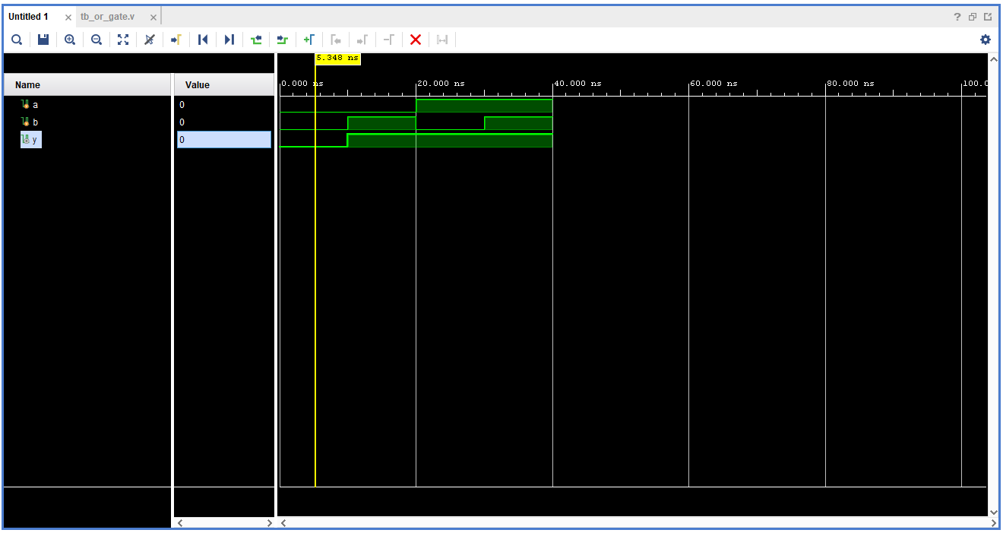 Tcl Console output:
a=0 b=0 y=0
a=0 b=1 y=1
a=1 b=0 y=1
a=1 b=1 y=1

6. Synthesis Observations
SCHEMATIC:
- 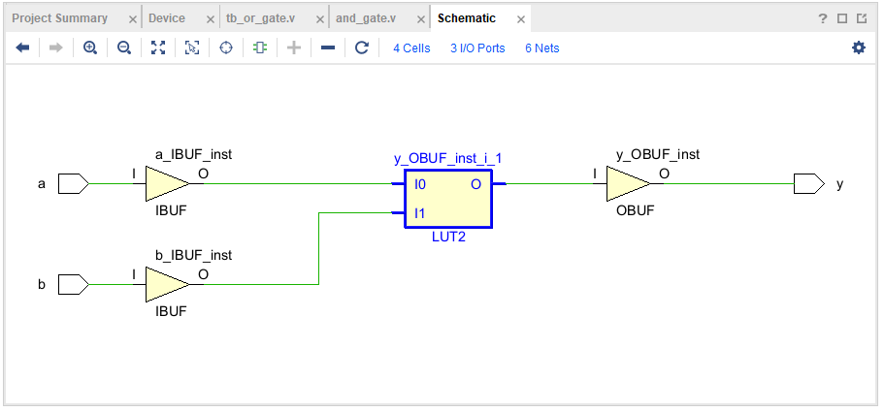Mapping: LUT2 with input buffer (IBUF) and output buffer (OBUF) is the expected implementation on the selected Spartan-7 FPGA, provided synthesis optimizes the logic into one LUT.
- LUT initialization value: INIT: 4'hE (as observed).
The LUT initialization value 4'hE corresponds to the binary configuration 4'b1110. For a two-input LUT, this configuration produces an output of 1 for input combinations 01, 10, and 11, and an output of 0 for 00, implementing the OR function.

Gate 5 — NOR Gate Using OR + NOT

1. Objective
To design and verify a 2-input NOR gate by instantiating the previously designed OR and NOT gates using Verilog structural modeling.

2. Boolean Equation
Y = NOT (A OR B)

3. Verilog RTL — nor_gate.v
module nor_gate(
input a,
input b,
output y
);

wire o;

or_gate n1 (
.a(a),
.b(b),
.y(o)
);

not_gate n2 (
.a(o),
.y(y)
);

endmodule

4. Testbench — tb_nor_gate.v
`timescale 1ns / 1ps

module tb_nor_gate;

reg a;
reg b;
wire y;

nor_gate dut (
.a(a),
.b(b),
.y(y)
);

initial begin
a = 0; b = 0; #10;
$display("a=%b b=%b y=%b", a, b, y);

a = 0; b = 1; #10;
$display("a=%b b=%b y=%b", a, b, y);

a = 1; b = 0; #10;
$display("a=%b b=%b y=%b", a, b, y);

a = 1; b = 1; #10;
$display("a=%b b=%b y=%b", a, b, y);

$finish;
end

endmodule

5. Truth Table
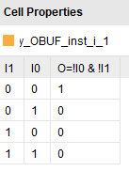

WAVEFORM
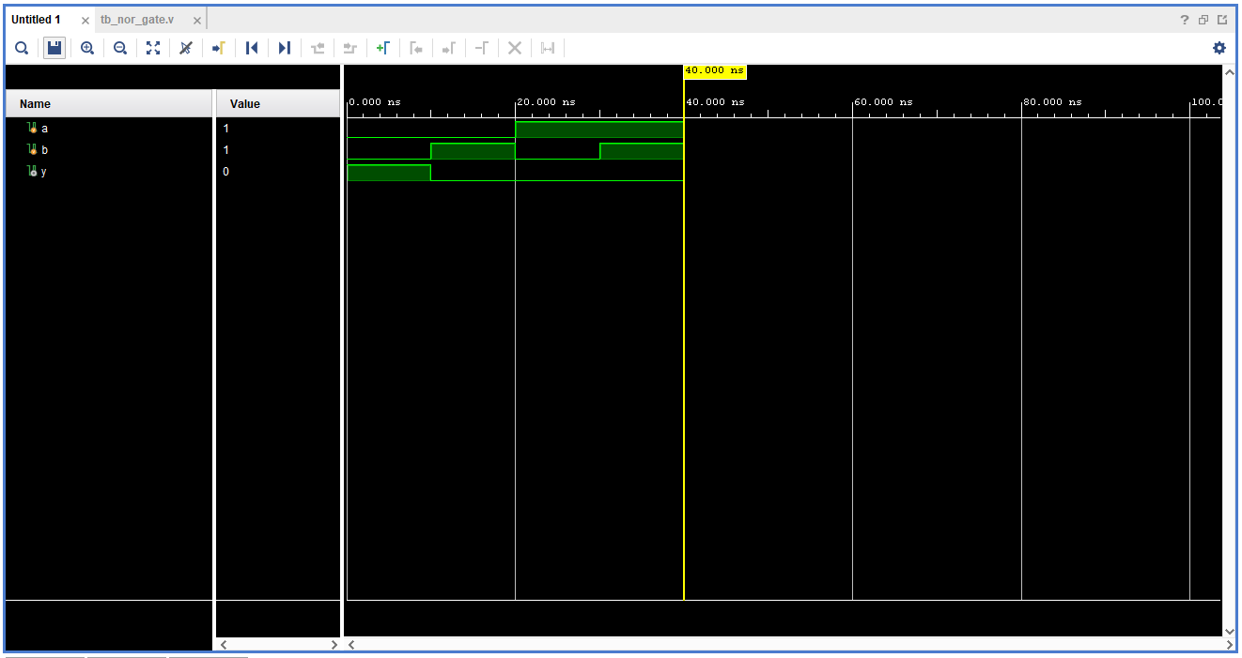 Tcl Console output:
a=0 b=0 y=1
a=0 b=1 y=0
a=1 b=0 y=0
a=1 b=1 y=0

6. Synthesis Observations
SCHEMATIC:
- 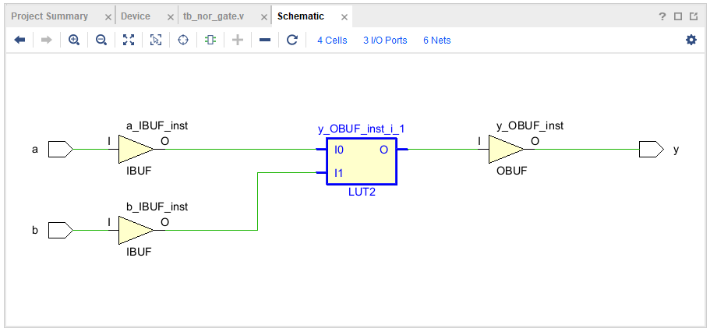Mapping: LUT2 with input buffer (IBUF) and output buffer (OBUF) is the expected implementation on the selected Spartan-7 FPGA, provided synthesis optimizes the logic into one LUT.
- LUT initialization value: INIT: 4'h1 (as observed).
The LUT initialization value 4'h1 corresponds to the binary configuration 4'b0001. For a two-input LUT, this configuration produces an output of 1 only when both inputs are 0, implementing the NOR function.

Gate 6 — XOR Gate Using Four NAND Gates

1. Objective
To design and verify a 2-input XOR gate by instantiating four previously designed NAND gates using Verilog structural modeling.

2. Boolean Equation
$$Y = A(B)' + (A)'B$$

3. Verilog RTL — xor_gate.v

module xor_gate(
input a,
input b,
output y
);

wire n1;
wire n2;
wire n3;

nand_gate g1 (
.a(a),
.b(b),
.y(n1)
);

nand_gate g2 (
.a(a),
.b(n1),
.y(n2)
);

nand_gate g3 (
.a(b),
.b(n1),
.y(n3)
);

nand_gate g4 (
.a(n2),
.b(n3),
.y(y)
);

endmodule

4. Testbench — tb_xor_gate.v
`timescale 1ns / 1ps

module tb_xor_gate;

reg a;
reg b;
wire y;

xor_gate dut (
.a(a),
.b(b),
.y(y)
);

initial begin
a = 0; b = 0; #10;
$display("a=%b b=%b y=%b", a, b, y);

a = 0; b = 1; #10;
$display("a=%b b=%b y=%b", a, b, y);

a = 1; b = 0; #10;
$display("a=%b b=%b y=%b", a, b, y);

a = 1; b = 1; #10;
$display("a=%b b=%b y=%b", a, b, y);

$finish;
end

endmodule

5. Truth Table

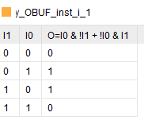

WAVEFORM
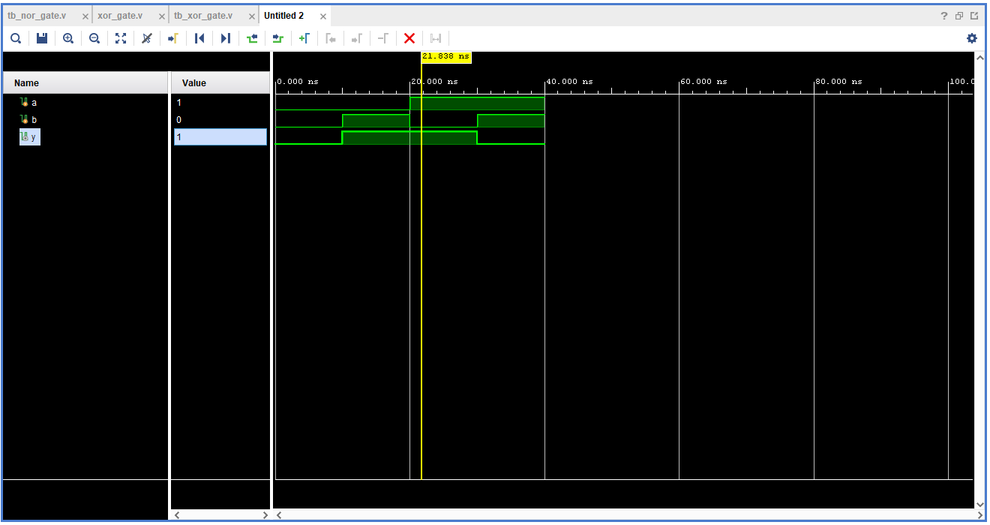
Tcl Console output:
a=0 b=0 y=0
a=0 b=1 y=1
a=1 b=0 y=1
a=1 b=1 y=0

6. Synthesis Observations
SCHEMATIC:
- 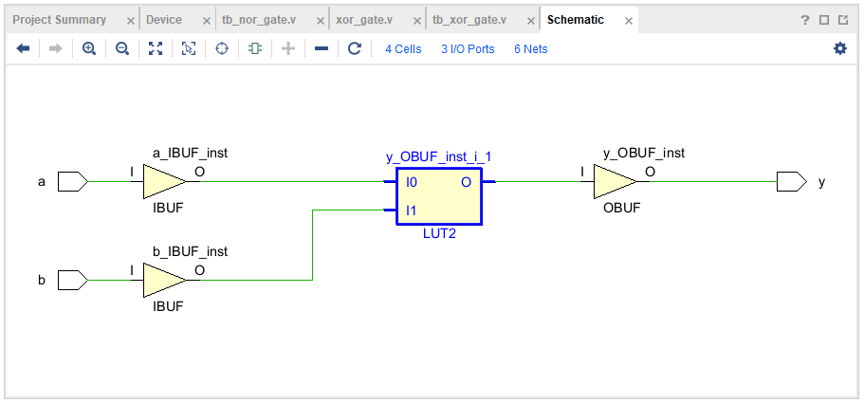Mapping: LUT2 with input buffer (IBUF) and output buffer (OBUF) is the expected implementation on the selected Spartan-7 FPGA, provided synthesis optimizes the logic into one LUT.
- LUT initialization value: INIT: 4'h6 (as observed).
The LUT initialization value 4'h6 corresponds to the binary configuration 4'b0110. For a two-input LUT, this configuration produces an output of 1 when the inputs differ (01 or 10) and an output of 0 when the inputs are equal (00 or 11), implementing the XOR function.

Gate 7 — XNOR Gate Using XOR + NOT

1. Objective
To design and verify a 2-input XNOR gate by instantiating the previously designed XOR and NOT gates using Verilog structural modeling.

2. Boolean Equation
$$Y = AB + (A)'(B)'$$

3. Verilog RTL — xnor_gate.v
module xnor_gate(
input a,
input b,
output y
);

wire x;

xor_gate n1 (
.a(a),
.b(b),
.y(x)
);

not_gate n2 (
.a(x),
.y(y)
);

endmodule

4. Testbench — tb_xnor_gate.v
`timescale 1ns / 1ps

module tb_xnor_gate;

reg a;
reg b;
wire y;

xnor_gate dut (
.a(a),
.b(b),
.y(y)
);

initial begin
a = 0; b = 0; #10;
$display("a=%b b=%b y=%b", a, b, y);

a = 0; b = 1; #10;
$display("a=%b b=%b y=%b", a, b, y);

a = 1; b = 0; #10;
$display("a=%b b=%b y=%b", a, b, y);

a = 1; b = 1; #10;
$display("a=%b b=%b y=%b", a, b, y);

$finish;
end

endmodule

5. Truth Table

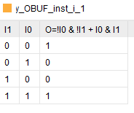

WAVEFORM
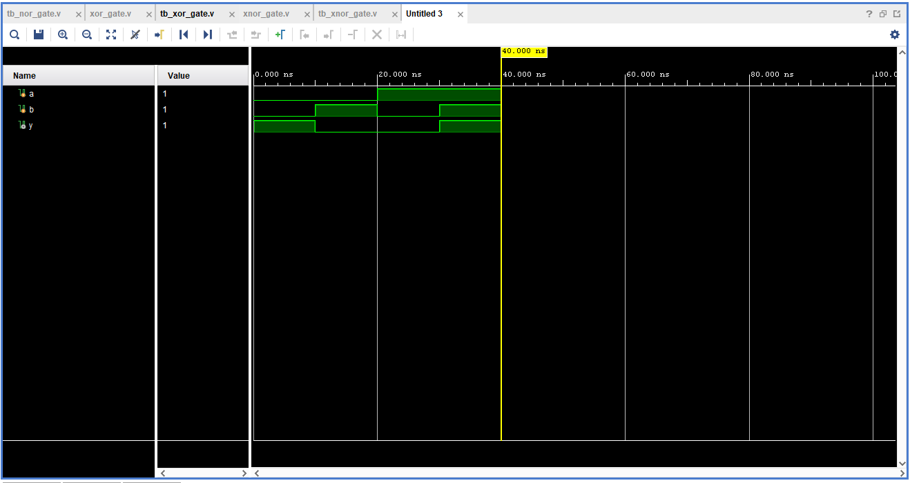
Tcl Console output:
a=0 b=0 y=1
a=0 b=1 y=0
a=1 b=0 y=0
a=1 b=1 y=1

6. Synthesis Observations
SCHEMATIC:
- 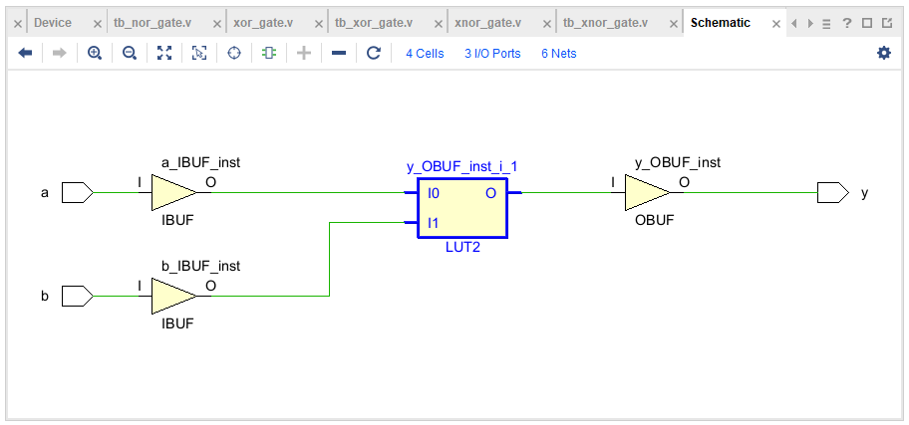Mapping: LUT2 with input buffer (IBUF) and output buffer (OBUF) is the expected implementation on the selected Spartan-7 FPGA, provided synthesis optimizes the logic into one LUT.
- LUT initialization value: INIT: 4'h9 (as observed).
The LUT initialization value 4'h9 corresponds to the binary configuration 4'b1001. For a two-input LUT, this configuration produces an output of 1 when both inputs are equal (00 or 11) and an output of 0 when the inputs differ (01 or 10), implementing the XNOR function.

